Using Models to Understand Photosynthesis

During photosynthesis, plants use carbon dioxide, water, and the energy in sunlight to produce oxygen plus sugar molecules with high stored chemical energy. Thus, photosynthesis converts light energy to stored chemical energy.

A scientific model is a simplified representation of reality that highlights certain key features of a structure, process or system. A good model helps us to understand a process such as photosynthesis.

A chemical equation is one type of model of photosynthesis. In the box below, the first version of the chemical equation for photosynthesis shows the chemical formula for each type of molecule, and the second version shows diagrams of the structure of each type of molecule. Notice that the atoms in the CO₂ and H₂O molecules are reorganized as atoms in O₂ and C₆H₁₂O₆ (the sugar glucose). Although the atoms stay the same, the product glucose has multiple C-C and C-H bonds which have higher stored chemical energy than the C=O and O-H bonds in the input CO₂ and H₂O.

Photosynthesis
sunlight
6 CO₂ + 6 H₂O 6 O₂ + C₆H₁₂O₆
6 |  | + | 6 |  | sunlight | 6 |  | +

1. During biological processes, energy can be converted from one type to another, but energy is neither created nor destroyed. During photosynthesis, what happens to the energy in sunlight? Be specific.

2. The chart below shows another type of model of photosynthesis. This model emphasizes that:
- One type of energy is converted to another type of energy.
- Matter is converted to matter; i.e. atoms in the input molecules are reorganized as atoms in the output molecules.
- Energy is not converted to matter or vice versa.
Complete this chart to show the changes during photosynthesis.

Energy Input  Matter Inputs | Photosynthesis  >>>>>>>>>>>>>> | Energy Output  Matter Outputs
Photosynthesis takes place in chloroplasts which are abundant in leaf cells. This diagram of a chloroplast provides another model of photosynthesis.  This model shows some of the multiple steps involved in synthesizing a single sugar molecule and a few of the many molecules needed for photosynthesis. Another important molecule is chlorophyll, a green pigment which absorbs light and begins the process of converting light energy to chemical energy.  In a real chloroplast, there are many repeats of each of the molecules and structures shown here.  3. Circle the part in the chloroplast where you would expect chlorophyll to be located. |  | 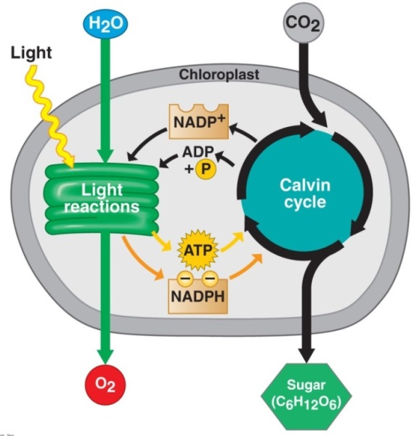

4. A typical leaf is flat and thin. Why is it useful for each leaf cell to be relatively near the surface of the leaf?

5. All three models of photosynthesis (the diagram above and the chemical equations and chart on page 1) show some of the same basic characteristics of photosynthesis. What are some basic characteristics of photosynthesis that are shown in all three of these models of photosynthesis?

6. Compare the three types of models – the diagram, the chemical equations and the chart. Describe one advantage of each type of model that helps you to better understand photosynthesis.

Advantage of the Diagram  (this page) | Advantage of the Chemical Equations (p. 1) | Advantage of the Chart  (p. 1)

The sugar molecules produced by photosynthesis are useful for two reasons. As shown on the next page, the chemical energy stored in the sugar molecules can be transferred to ATP molecules which provide the energy for cellular processes. In addition, plant cells use some of the sugar molecules to synthesize other needed molecules such as cellulose and amino acids.

All biological organisms use ATP to provide energy for many of the molecular and cellular processes required for life.

Cellular Respiration is the process that transfers some of the chemical energy in glucose or another organic molecule to chemical energy in ATP.

This figure shows how photosynthesis and cellular respiration work together to produce the ATP that plants need.

Some of the glucose produced by photosynthesis is not used for cellular respiration, but instead is used by the plant to synthesize other molecules such as starch, cellulose and amino acids. At night, starch molecules can be broken down to provide glucose for cellular respiration. Other molecules such as cellulose and amino acids are used for growth.
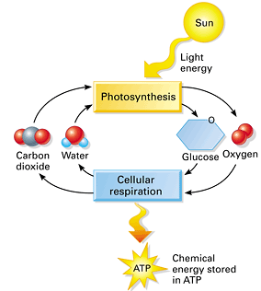

7. Complete the chart below to show a model of the relationships between photosynthesis, cellular respiration, and other processes in the plant.
- Show the chemical equation for photosynthesis.
- Draw arrows to link the glucose produced by photosynthesis to the glucose used by cellular respiration and to the glucose used in the synthesis of other biological molecules.
- Draw an arrow to show that starch can be broken down to provide glucose molecules for cellular respiration.

Photosynthesis

Cellular Respiration

C₆ H₁₂O₆ + 6 O₂ 6 CO₂ +6 H₂O
\/
energy
\/
ADP + P_{i} ATP

Glucose is used in the synthesis of other biological molecules such as starch, cellulose and amino acids.

\/\What
ATP is used to provide energy for biological processes.
c

8. In the dark, a plant produces more CO₂ than it takes in. Explain why.

9. In the light, a growing plant takes in more CO₂ than it produces. Explain why. Where do the carbon atoms from the CO₂ go?

By Dr. Ingrid Waldron, Dept. Biology, University of Pennsylvania, © 2014. Teachers are encouraged to copy this Student Handout for classroom use. This Student Handout and Teacher Notes are available at http://serendip.brynmawr.edu/exchange/bioactivities/modelenergy.

